Git laboratorio –

Creación del repositorio - publico

Token creación

Git instalado

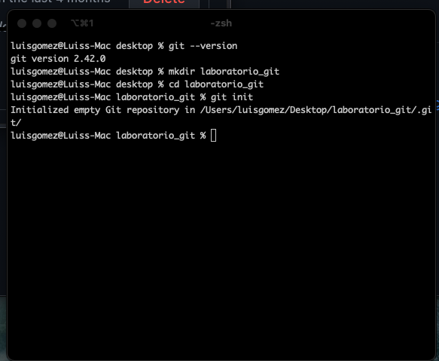

Repositorio clonado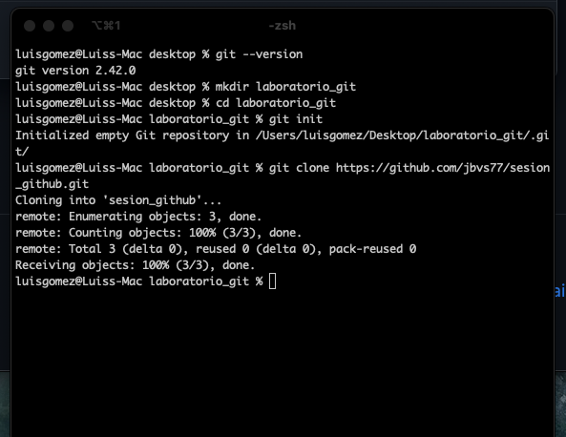

Git branches creation

Modificando y haciendo el primer pull

Fusionando commits y haciendo pull

Qa git Branch

